New Computer Language Coding Concepts

Interface Connections
Below you will find the possible connections for the Interface aspect and the Interface Merged aspect. A connection is the result of a call to a system command. However, the result of call to the Interface Merged Set command is that the reference becomes a triangle or a circle shape. This result is also presented in this overview.

Use As Interface | Interface Set
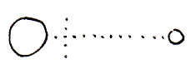 | 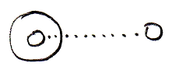
Interface Merged = True |  | Interface Merged = False
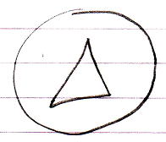 |  | 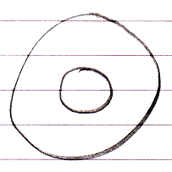

Author & Copyright: Jan-Joost van Zon Date: May 7, 2010 – May 7, 2010 Location: Oosterhout, The Netherlands Status: Finished

